1. DISPLAY ALL 10 EMPLOYEE DATA

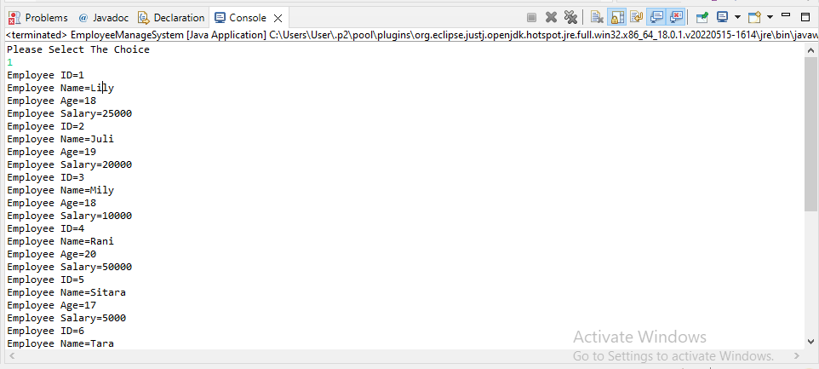

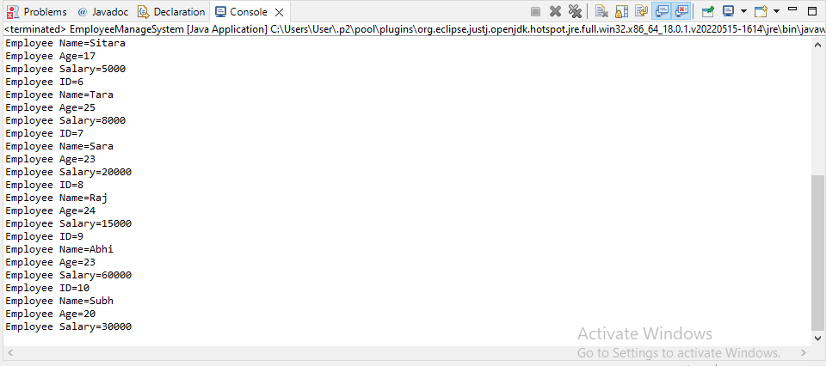

1. ARRAMGE IN DECENDING ORDER

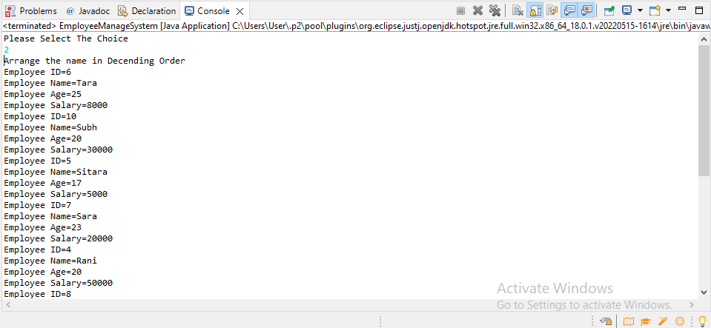

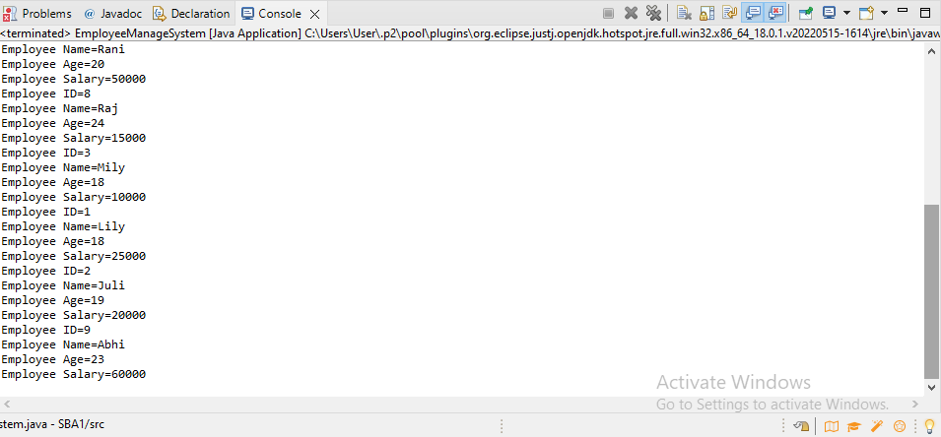

1. UPDATED DETAILS

